BEVERLEY SUTHERLAND SMITH
COOKING SCHOOL

29 REGENT STREET, MT. WAVERLEY

TELEPHONE 9802 5544

Winner of the Monash Business Award for Micro Home Based Business 2002-2003
www.beverleysutherlandsmith.com.au
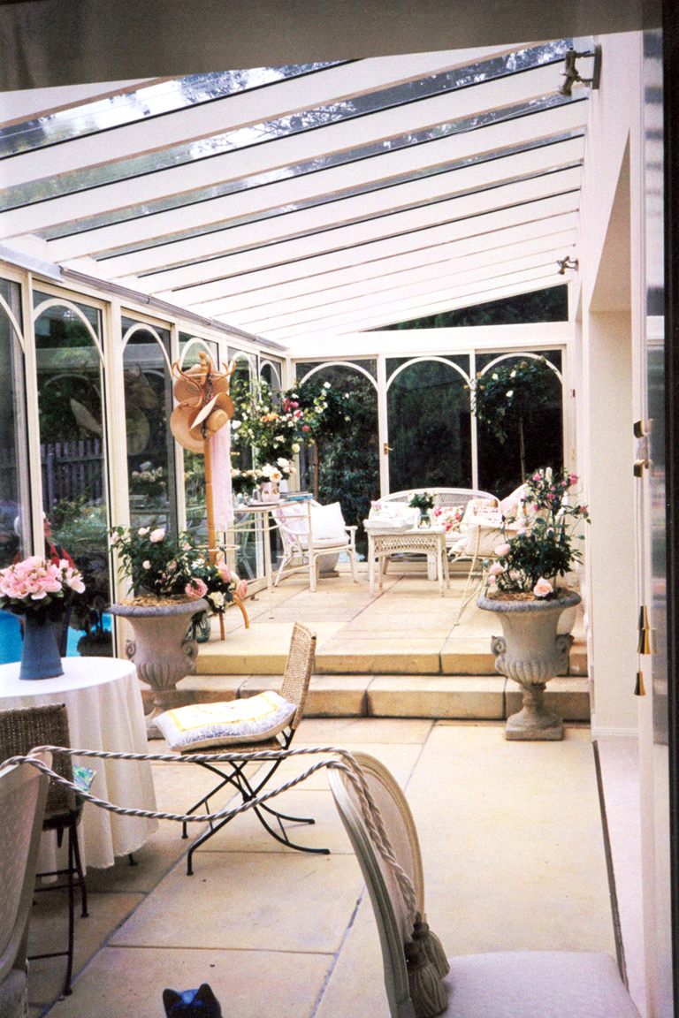

Inside this 1st Issue for 2011  Hands on BBQ (1, 2 & 3) participation Classes  Demonstrations:  - Small Savoury Tarts (New)  - Tapas (Repeat – Hands On)  - Popular Products of the Moment (New)  - After Dinner Cakes (New)  - Dinner Party (New)  - Dishes in Glasses (New)  - Tapas and Paella (New)  - Brunch for Fun (New)  Order of Demonstration classes & change of Brunch & Casual Dining class.  Products are available through the School  Enrolment Form  Travel News  Join us for a fabulous Gourmet and Cultural Tour of Istanbul & Cappadocia  Information Evening on:  SUNDAY, 6 MARCH at 5.00 pm  29 Regent St, Mount Waverley.  Drinks and nibbles. | END OF AN ERA –  As many of you know, my daughter Suzanne and I have been looking for a retail shop to expand our presence and we believe we have found the perfect shop in High Street, Prahran.  We are now setting up the shop with the hope of opening in July. Until this happens, classes will be in Mt Waverley as usual, then some will be transferred to Prahran.  There will still be some special events this year, for example, to mark the 45 years of the school. In the new shop, we intend to give classes for young ”masterclass” enthusiasts, will sell our hand made produce, have gourmet takeaway and catering. The new business will be called “The Seasonal Kitchen”, inspired by my last book of the same title, the garden and our commitment to fresh seasonal produce.  Mt Waverley School will still be available if you wish to book for lunches, dinners, birthdays etc.  The new gourmet eatery will also be available for special private dinners and children’s parties.  You will be able to follow our progress from March on our website.  For those of you who have an email address, please let us know and we will put you in the data base for future communication.

CLASS PROGRAMME

This programme is for the first part of 2011 and a second brochure will be prepared with classes for the second half of the year.

Beverley, a passionate cook and teacher, has been operating her cooking school since 1967. You will be welcomed with tea or coffee and homemade biscuits or cake on arrival. Classes are small, the atmosphere is warm and friendly and a copy of all recipes is handed out. Demonstrations cover many options for cooking from easy and simple food to more elaborate dishes. Hints and techniques are given, generous tastings, interesting wines, and the opportunity to wander in ‘The Edible Garden’. The cooking school has been operating now for nearly forty-five years and we would love to see some of our regular and very special clients again this year as we go through changes.

How to find us:
Access to the Cooking School via the S-E Freeway. Turn off at Forster Road exit and continue right into Waverley Road. Regent Street is only a couple of streets down on the left. Except in peak hour traffic, it takes around 15 to 20 minutes from the city.

HANDS ON BBQ PARTICIPATION CLASSES

These classes proved to be very popular in our 2009 programme. A substantial luncheon and wines are included in addition to the recipes; class size is restricted to 8 people under the personal instruction of Beverley, representing great fun and value. If you have a gift voucher, please mention this when making your booking and bring the form with you on the day.

BARBECUE COOKING (1)
Prepare a range of marinated meat, fish, poultry with different techniques as diverse as skewered orange lamb, individual foil packages of lemon grass and ginger prawn, basil chicken and more. Lots of fun working together, informative and suitable for any age group. After the hands on preparation, the food is cooked on the barbecue with accompaniments of salads and wines to match. Dessert is then served. Even if the weather is not kind we have under cover facilities for cooking on the barbecue.
Classes commence 11 am and usually finish about 2.30 to 3 pm.

Dates for Barbecue (1) Saturday, March 19 11.00 am

BARBECUE COOKING (2)
Due to the popularity of the BBQ class, Beverley has created a second BBQ lesson. This is suitable for people who have attended and loved our first class, as well as those who wish to expand their repertoire with BBQ style cooking. This class will include a range of salad accompaniments to BBQs, including how to make the best French potato salad, a way to make ordinary tomatoes really flavoursome and of course meat, fish and vegetable BBQ dishes. As each class is complete in itself you do not need to have done Barbecue (1) to come to (2)

Dates for Barbecue (2) Saturday, 16 April 11.00 am

BARBECUE COOKING (3)
Asian inspired dishes, marinades and some accompaniments to food that has spicy and aromatic flavours. Includes chicken, beef and fish dishes.

Dates for Barbecue (3) Sunday, 10 April 11.00 am

Tuition Fee: $90
__________________________________________________________________________

Gift Certificates
Don’t know what to give that special person? Why not give them a Gift Certificate to one of our classes.
When booking please advise us you are using a gift certificate and this is sufficient to hold your booking for a class. Please bring the certificate with you to the lesson for redemption. A Single Class gift certificate can be used for any single lesson, or if you prefer, you can attend one of the two week class lessons. If you wished to attend both, an additional $85 is payable. Please send your payment - cheques made payable to Beverley Sutherland Smith, or nominate that a gift certificate is being used, to confirm your booking. You will be notified immediately if this date or booking is not available.

DEMONSTRATIONS

If you wish for more detailed descriptions of the classes, this is featured on our web site www.beverleysutherlandsmith.com.au as we test the recipes or you can always ring us in the cooking school. Some dishes are not decided upon until nearer the time of the class as we are always testing and choosing the best from our repertoire. A second brochure will be sent out later in the year and include classes such as mini dessert tarts, finger food, spring time specials and of course our festive class.

SPANISH TAPAS (One lesson) (REPEAT – HANDS ON))

For years, Spanish food has been acclaimed as some of the most creative and tasty of any country and restaurants are booked out for months ahead. This is a lesson on their delicious and interesting little tapas dishes. Dishes perfect for summer entertaining either as finger food or part of a buffet. You will cook them in a group and eat with a tasting of Spanish sherry and wine.

Sunday, 13 March, 2011 4 pm
Tuition Fee: $90

SMALL SAVOURY TARTS (Single Lesson) (NEW)

A collection of small savoury tarts – These are individual dishes are for all occasions with a variety of savoury fillings. The cases can be frozen so you can put together a beautiful first course quickly for family or friends.

Tuesday, 15 March, 2011 10.15 am or 7 pm
Tuition Fee: $85

POPULAR PRODUCTS (Single Lesson) (NEW)

Some products come into fashion in the food industry and we shall have fun looking at a variety of the “in” food products such as Yuzu juice, Pomegranate Molasses, Fenugreek grains for example and ways to use them to create some different flavours.

Tuesday, 22 March, 2011 10.15 am or 7 pm
Tuition Fee: $85

AFTER DINNER CAKES (Single Lesson) (NEW)

I love light and beautifully styled homemade cakes to serve after dinner parties with coffee instead of dessert for a change. This lesson demonstrates a few of my latest favourites.

Tuesday, 29 March, 2011 10.15 am or 7 pm
Tuition Fee: $85

DINNER PARTY (Two Lessons) (NEW)

Dinner parties are always popular and have changed so much since we first gave classes, now they can be more informal but still special food worthy of our best friends. These dinners will give you some new ideas for 3 course combinations.

Tuesday, 5 & 12 April, 2011 10.15 am or 7 pm
Tuition fee: $170 for double lesson
________________________________________________________________________________
.
DISHES IN GLASSES

Food served in verrines (or glasses) has become so fashionable and on my last trip to Paris, everywhere you went, exquisite little dishes appeared as either a first course or dessert. Layered with colour and texture, we shall do a selection of these tiny, tasty treats with their toppings and decorations.
.
Tuesday, 3 May , 2011 10.15 am or 7 pm
Tuition fee: $85
_________________________________________________________________________

TAPAS AND PAELLA (Double Lesson ) (NEW)

A demonstration class with a great selection of wonderful selection of dishes (these will be quite different from our hands on Tapas class). You will enjoy a Spanish party paella, the most popular dish is so many areas of Spain and during this lesson we will enjoy some tastings on Spanish ingredients such as Serano ham and Manchego cheese.
.
Tuesday, May 31 & June 7, 2011 10.15 am or 7 pm
Tuition fee: $170

BRUNCH AND CASUAL DINING (Single Lesson) (NEW)

Café food has become incredibly popular in the last year it seems everyone you speak with wants to open a café, serving brunch, or casual food. Café food is great for a light dinner when you want to serve something delicious but in a casual mood.

Tuesday, 21 June, 2011 10.15 am or 7 pm
Tuition fee: $85

Terms & Conditions For Booking Classes:

We can take telephone bookings or fill out the enclosed form and either post or fax. Payment is required in advance before each class and is non refundable. Should you be unable to attend, you may transfer to another class provided 10 days notice is given.

If cancellation is within the 10 days, you can ask for a refund. Or if something should happen and you cannot attend you can always send a substitute person on the day. If you are unable to do this, we will provide you with a copy of the recipes from the lesson.

FUNCTIONS / CATERING

BOOK THE COOKING SCHOOL EXCLUSIVELY FOR YOUR NEXT SPECIAL OCCASION –
An intimate alternative to restaurants. For bookings and pricing telephone: 9802 5544.

The Cooking School, which becomes a garden room for functions and the beautiful Conservatory are proving popular for birthdays, parties, special anniversaries, corporate functions, charity fundraisers, AGM’s and small wedding parties. You and your guests will have the room completely to yourself when you book.

Start your function with champagne cocktail by the pool, or in the conservatory. It is a unique setting and gives an opportunity for speeches in private without obtrusive background noise as so often happens in restaurants. And of course, delicious catering by Beverley with a menu of your choice.

COOKBOOKS
Books are always available through classes but if you would like to order through the mail any of the following books can be sent. Books will be personally autographed for you.

- Finger Food Book  - Brunch, Lunch & Casual Meals  - Mini Munchies | - Class Recipe Book  - Festive Class Book  - Favourites
All books - Cost $20 (plus $10 postage & Handling)

DVD-CD - Beverley Sutherland Smith “Favourites” Vol 1 and Barbeques & Salads Vol. 2 DVD/CD
Cost: $25 inc. Postage & Handling.

CLASS ENROLMENT FORM

NAME:

ADDRESS: (Postal or email may be nominated):

TELEPHONE NUMBER:
Please enrol me for the following classes:

Name of Class | Date | Time of class  AM | Time of class  PM | Number of people | Tuition  Fee per person  (GST included)
Further information is on our website www.beverleysutherlandsmith.com.au
or email to: info@beverleysutherlandsmith.com.au

Phone bookings can be made 9802 5544. Fax enrolment form to 9802 7683
Or post to: Beverley Sutherland Smith,
P.O. Box 2134, Mount Waverley, VIC 3149

BOOKS & DVD ORDERS: I would like to order:

Name of book | Number of copies  @ $20/book( plus $10 Postage & Handling) | Name to appear on book for Beverley’s signing
Finger Food
Brunch, Lunch, Casual Meals
Class Recipe Book
Mini Munchies
Festive
Favourites
Favourites Vol 1  BBQ & Salads Vol 2 DVD/CD | $25 each (includes Postage & GST) | No. required:……..
□ Bank Card; □Visa; □Master Card; Expiry Date ____/____
□□□□ □□□□ □□□□ □□□□

Signature: _________________________________________

Name: ______________________________________________

Delivery address: _________________________________________
_______________________________ Post Code_______

Contact Number: ___________________ Total Amount $______________

Mail with payment (cheque or credit card to Beverley Sutherland Smith, Box 2134, Mt Waverley, 3149)

